Name: Abdullah

Father Name: Muhammad Akram

Roll No: KJPAFAD10111

**Q1: Solution:**

void main() {

  int maths = 90, physics = 85, chemistry = 80, urdu = 95;

  int sum = maths + physics + chemistry + urdu;

  double percentage = (sum / 400) * 100;

  print("======== Marksheet ================");

  print("");

  print("Marks in Maths:  $maths");

  print("Marks in Physics:  $physics");

  print("Marks in Chemistry $chemistry");

  print("Marks in Urdu  $urdu");

  print("Abdullah Total Marsk is : " +

      sum.toString() + // use .toString function to convert int value to string for concatenation

      " out of 400 and Percentage is: " +

      percentage.toString() +

      "%");

}

**Output:**

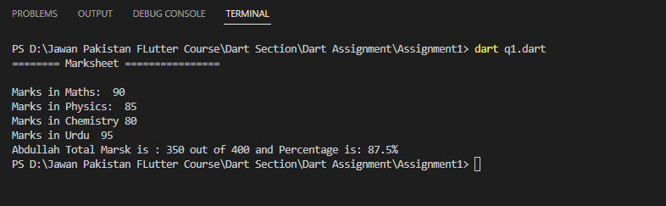

**Q2: Solution:**

void main() {

  num Fahrenheit = 120, Celsius = 40;

  num convertcel = ((Celsius) * 9 / 5) + 32;

  num convertfahren = (Fahrenheit - 32) * 5 / 9;

  print("Temperature of Fahrenheit is: $Fahrenheit");

  print("Temperature of Celsius is: $Celsius");

  print("");

  print("Temperature Fahrenheit to Celsius: $convertfahren C");

  print("Temperature Celsius to Fahrenheit: $convertcel F");

}

**Output:**

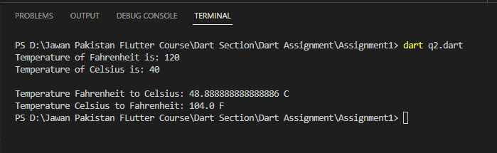

**Q3: Solution:**

import 'dart:math';

void main() {

  num base = 2, exponent = 3;

  num result = pow(base, exponent);

  print(

      "value of base is: $base and exponent is: $exponent and the final answer is: $result");

}

**Output:**

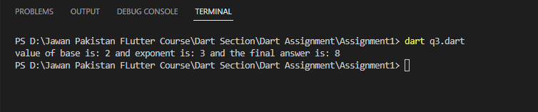

**Linkedin Profile Link:**

[www.linkedin.com/in/abdullah-malik-795a4a245](http://www.linkedin.com/in/abdullah-malik-795a4a245)

**Git Profile Link:**

<https://github.com/AbdullahMalike>